Student Name: Bhavya UID: 24BAI70791
Branch: BE-CSE(AIT) Section/Group: 24AIT_KRG2
Semester: 4 Date of Performance: 27/02/2026
Subject Name: Database Management System Subject Code: 24CSH-298

WORKSHEET 7
AIM:To design and implement a materialized view and to compare and analyze execution time and performance differences between simple views, complex views, and materialized views, thereby understanding their impact on query optimization and system performance.

2. Software Requirements
Database Management System:
- Oracle Database Express Edition (Oracle XE)
- PostgreSQL Database
Database Administration Tool / Client Tool:
- Oracle SQL Developer (for Oracle XE)
- pgAdmin (for PostgreSQL)

3. Objective
To create simple views, complex views, and materialized views, and to evaluate their performance by comparing query execution time for each, highlighting the advantages of materialized views in enterprise-level applications.

4. Procedure of the Experiment
- Open PostgreSQL (pgAdmin) / Oracle SQL Developer and connect to the database.
- Create the required tables (Employee, Department).
- Insert sample data into the tables.
- Verify the data using SELECT queries.
- Create a simple view using a single table.
- Execute the simple view to check output.
- Create a complex view using JOIN and aggregation.
- Create a materialized view to store computed results.
- Execute all views and analyze performance using EXPLAIN ANALYZE.
- Compare execution time and conclude that materialized view performs better.

PROBLEM STATEMENT:
In large-scale enterprise systems, frequent execution of complex queries can significantly affect performance. Optimized mechanisms are required to improve query response time without compromising data consistency.

TABLE STRUCTURE:

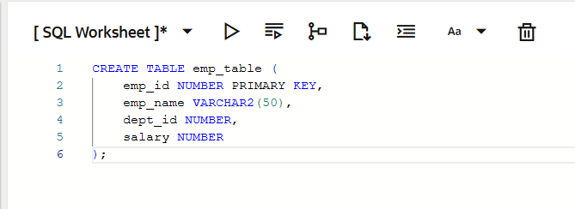

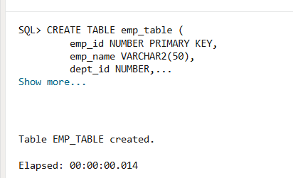
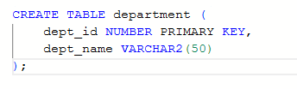
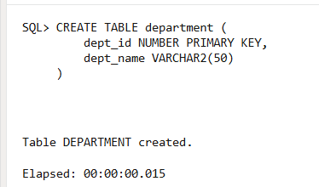
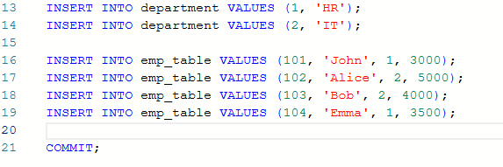
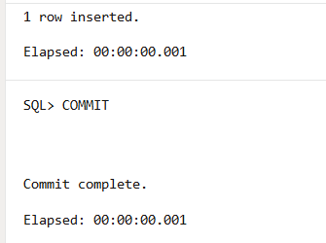

1. PROBLEM STATEMENT – Simple View

Create a simple view based on a single table.
PROGRAM:
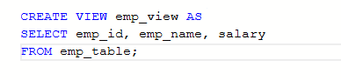
OUTPUT:
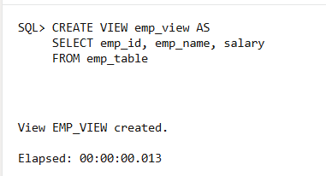

2. PROBLEM STATEMENT –Complex View
Create a complex view using join and aggregation.
PROGRAM:
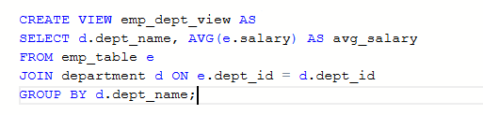
OUTPUT:
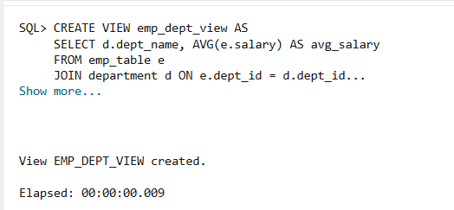

3. PROBLEM STATEMENT – Materialized View

Create a materialized view to store precomputed results.
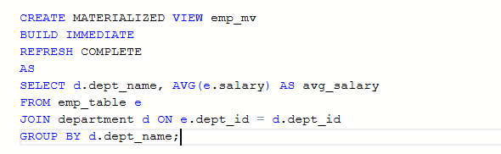
OUTPUT:
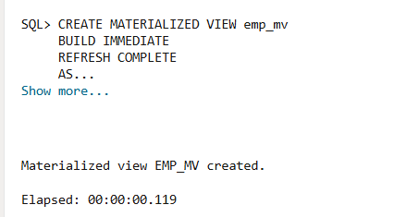
REFRESH MATERIALIZED VIEW:

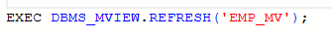
OUTPUT:
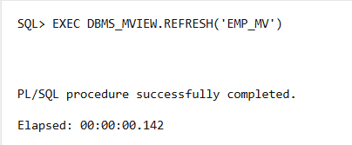

PERFORMANCE ANALYSIS:

QUERY ON SIMPLE VIEW:

OUTPUT:
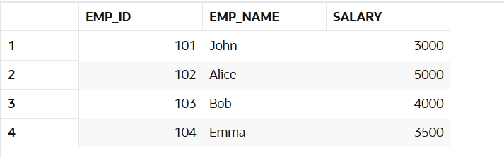
QUERY ON COMPLEX VIEW:

OUTPUT:
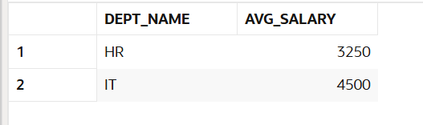
QUERY ON MATERIALIZED VIEW:

OUTPUT:
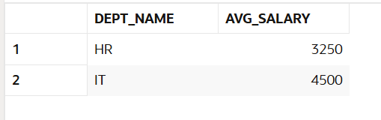

LEARNING OUTCOMES:
After completing this experiment, the learner will be able to:
- Understand the concept and working of materialized views in a database system.
- Differentiate between simple views, complex views, and materialized views.
- Create and refresh materialized views in PostgreSQL.
- Measure and compare query execution time for different types of views.
- Analyze performance benefits of materialized views in data-intensive applications.
- Apply materialized view concepts in real-world company scenarios such as SanDisk, JTG, and PayPal.

